AI ASSISTENT CODING - 11.4

P.Deepak
2303A52179
Batch – 42

Task 1: Stack Implementation for Undo Operations (LIFO)
Scenario
You are building a text editor where users can undo their recent actions
(typing, deleting, formatting). Each action must be reversed in Last-In-First-
Out (LIFO) order.

Prompt:
You are designing a text editor undo feature where actions must be reversed using the Last-In-First-Out (LIFO) principle.Generate a Python Stack class with methods push(action), pop(), peek(), and is_empty().
Provide a clean class skeleton with proper docstrings and comments.
Explain why a stack data structure is suitable for undo functionality.
Suggest and implement an alternative stack implementation using collections.deque.Include sample test cases that simulate undo operations and compare list-based vs deque-based stacks

Code:

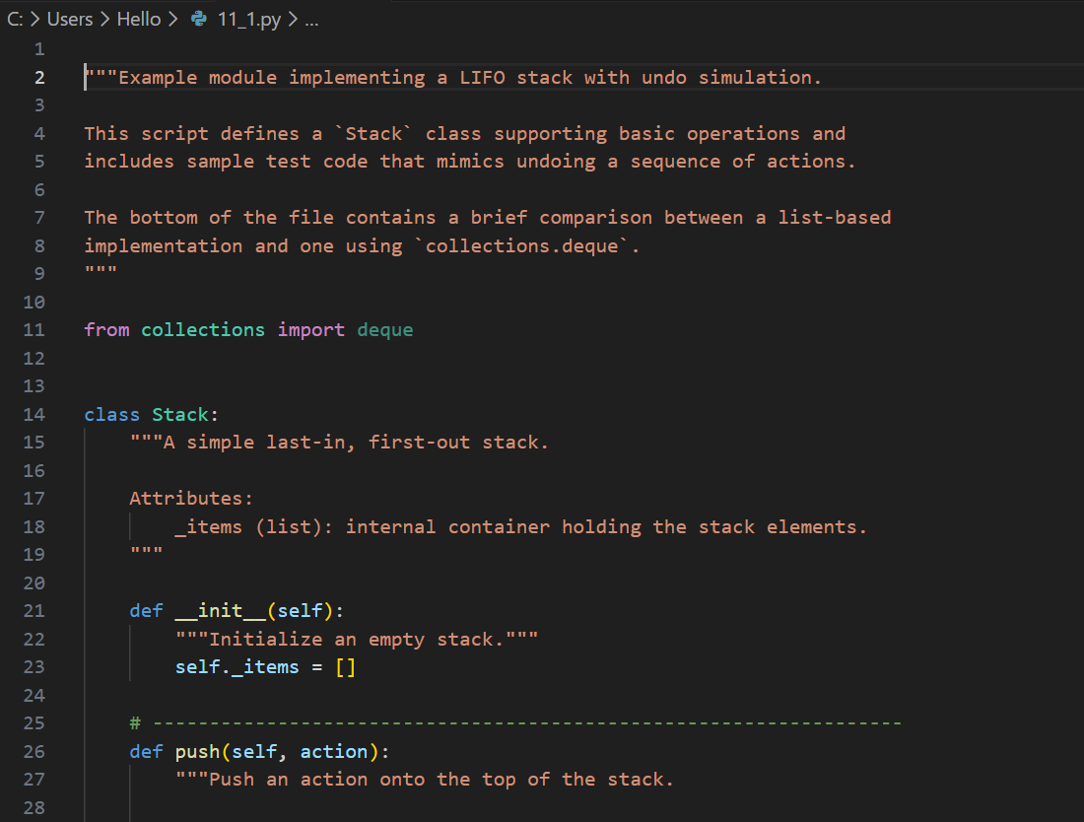
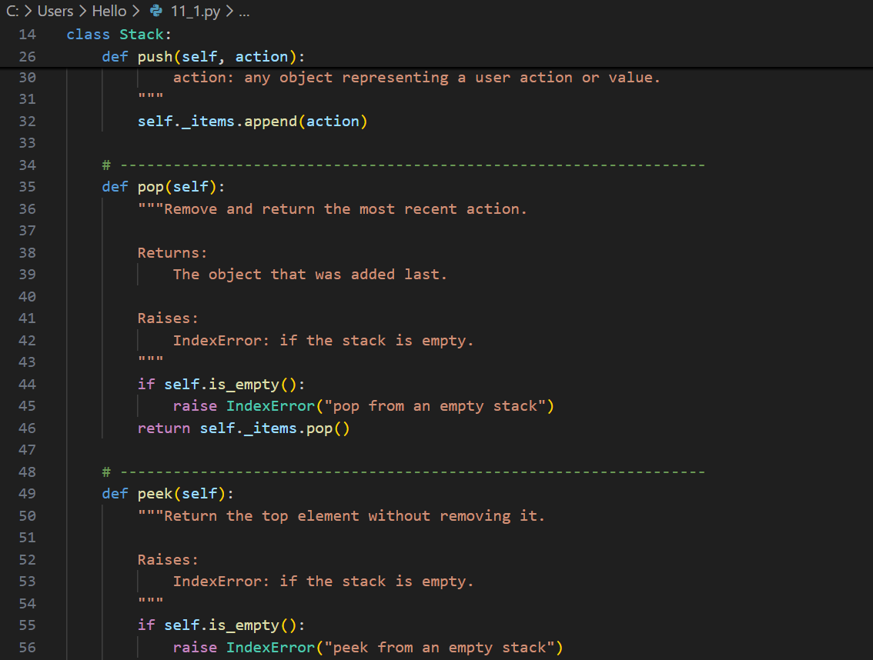
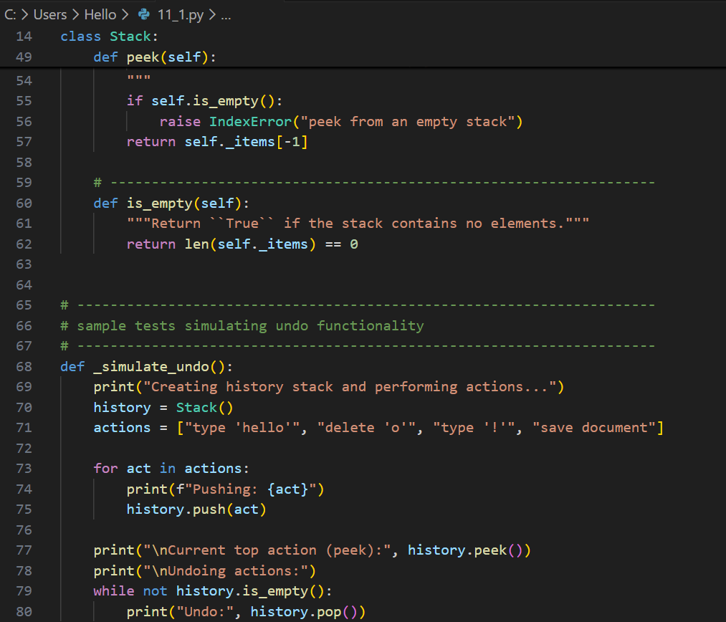
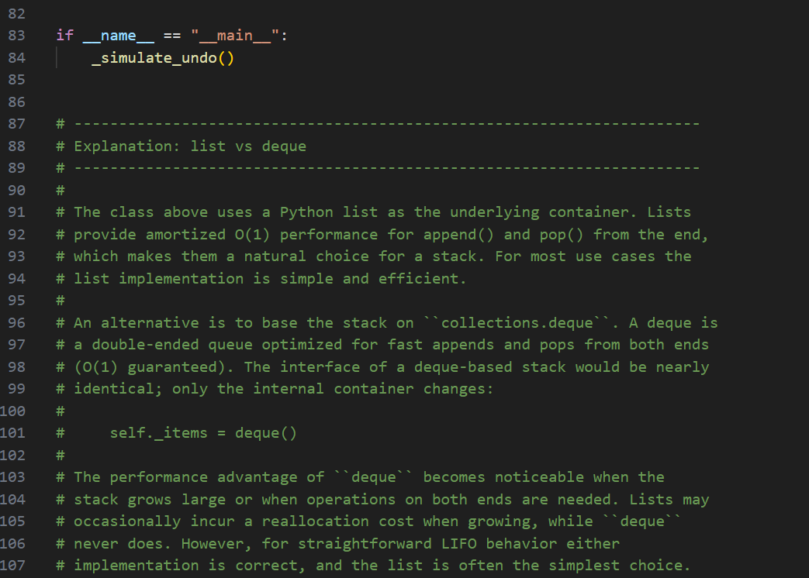

Output:
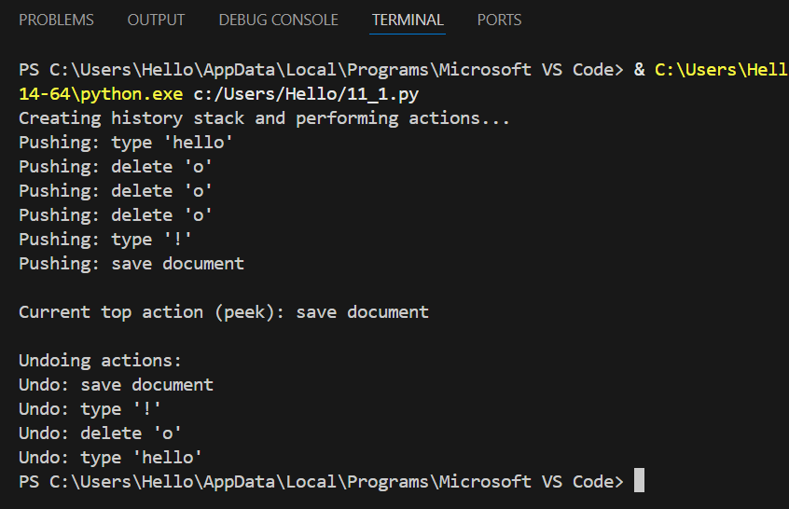

Justification:
Undo operations require reversing the most recent action first, which follows the LIFO principle.A stack naturally supports this behavior using push and pop operations.It ensures that the latest user action is undone before older actions.
The structure is simple and efficient for editor operations.Using a list provides easy implementation and understanding.A deque-based stack improves performance for frequent operations.

Task 2: Queue for Customer Service Requests (FIFO)
Scenario
You are developing a customer support system where service requests must
be handled in the order they arrive.

Prompt:
Generate a Python program to simulate a customer service request system using a Queue (FIFO).First, implement a Queue class using a Python list with methods enqueue(), dequeue(), and is_empty().
Then, review the performance issues of the list-based queue (especially dequeue operation).After that, suggest and implement an optimized Queue using collections.deque.

Code:
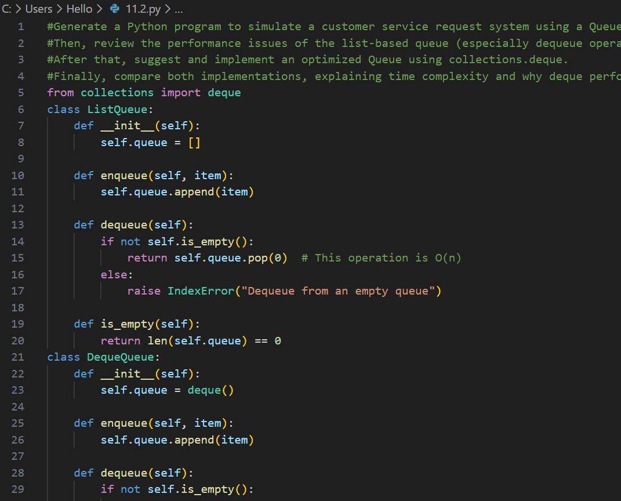

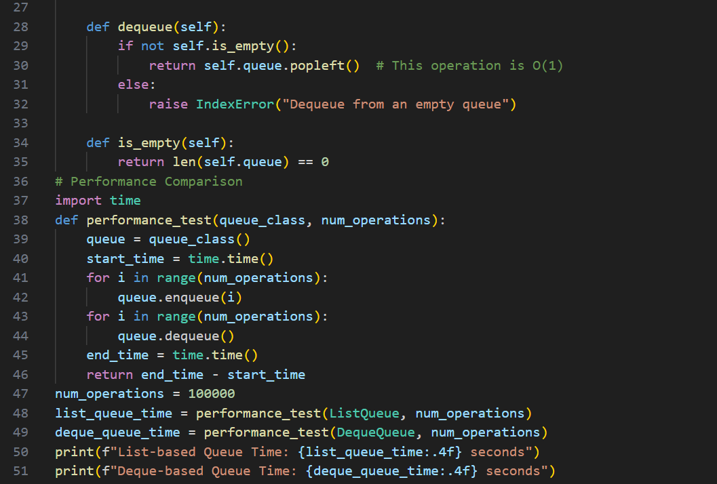

Output:
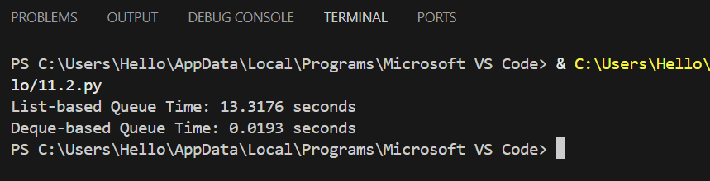

Justification:
Customer requests must be handled fairly in the order they arrive.A queue follows the FIFO principle, ensuring first-come-first-served service.List-based queues are easy to implement but inefficient for large data.
Deque allows faster insertion and deletion from both ends.This reduces waiting time and improves system performance.Queues ensure scalability in real-time customer service systems.

Task 3: Singly Linked List for Dynamic Playlist Management
Scenario
You are designing a music playlist feature where songs can be added or
removed dynamically while maintaining order.

Prompt:
Generate a Python program to manage a music playlist using a Singly Linked List.Implement a Node class and a SinglyLinkedList class with the methods.insert_at_end(song), delete_value(song), and traverse().
Add inline comments explaining how pointers (next) are updated during insertion and deletion.Clearly highlight tricky parts, especially deleting the head node and traversing the list.Also, suggest and include edge case test scenarios such as an empty list, single-node list, and deletion of the first song.

Code:
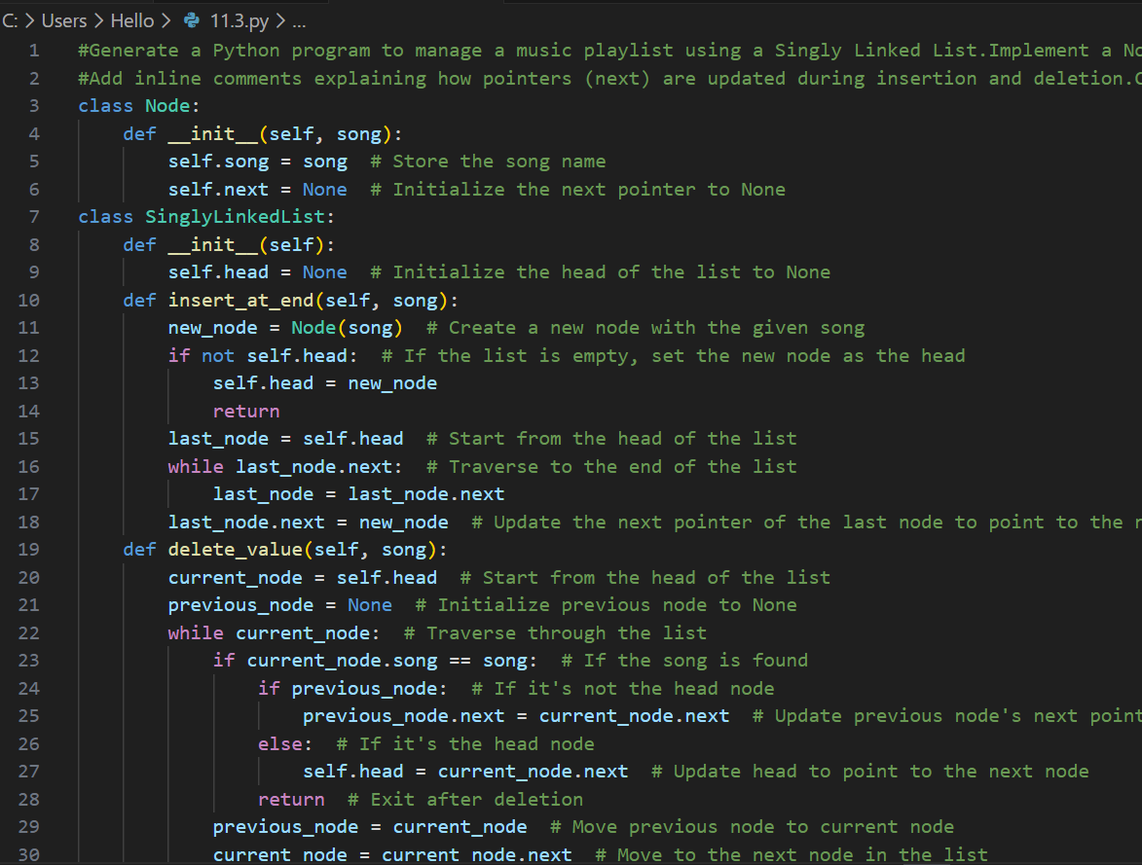
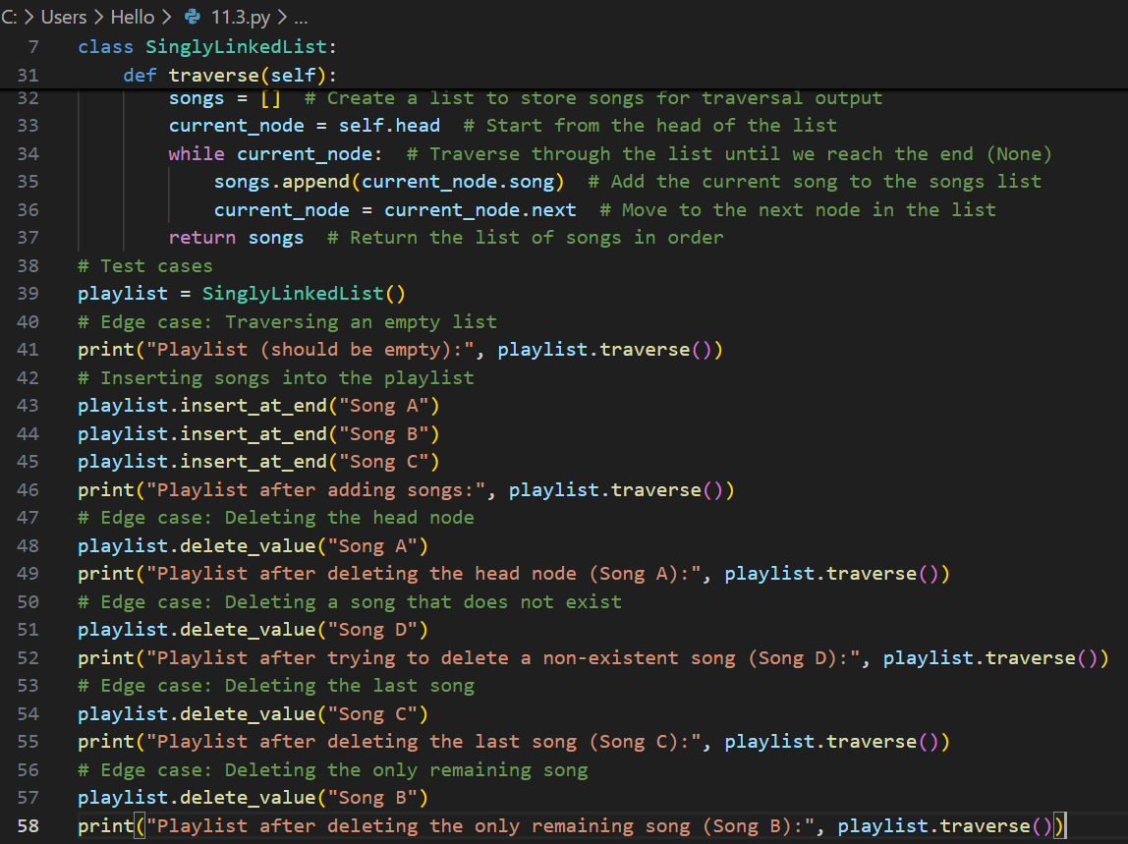

Output:
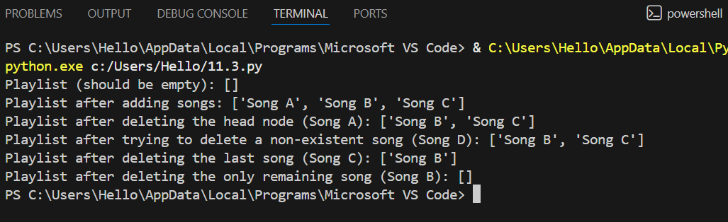

Justification:
A playlist requires dynamic addition and removal of songs.Linked lists allow efficient memory usage without shifting elements.Insertion and deletion are done by updating pointers.This maintains the order of songs in the playlist.
Edge cases like empty or single-node lists are handled easily.Linked lists are suitable for frequently changing data collections.

Task 4: Binary Search Tree for Fast Record Lookup
Scenario
You are building a student record system where quick searching by roll
number is required.

Prompt:
You are given a partially implemented Node and Binary Search Tree (BST) class in Python for a student record system where roll numbers are used as keys.
Complete the missing methods insert(value), search(value), and
inorder_traversal().
Add meaningful docstrings explaining the purpose of each method.
Ensure the BST maintains correct ordering properties during insertion.
Finally, explain how BST search is more efficient than linear search, including best-case and worst-case time complexity.

Code:
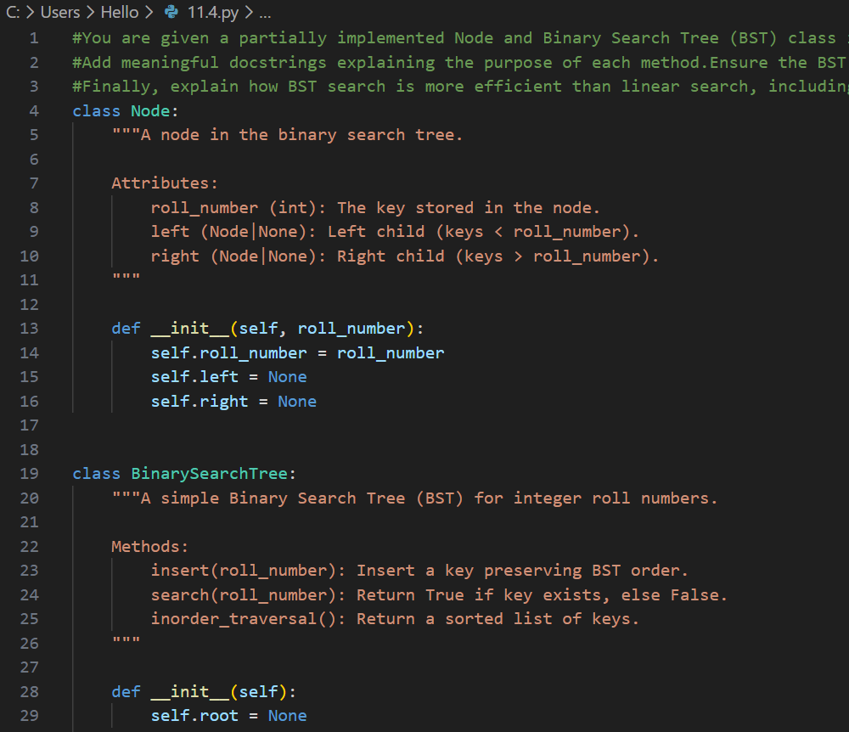
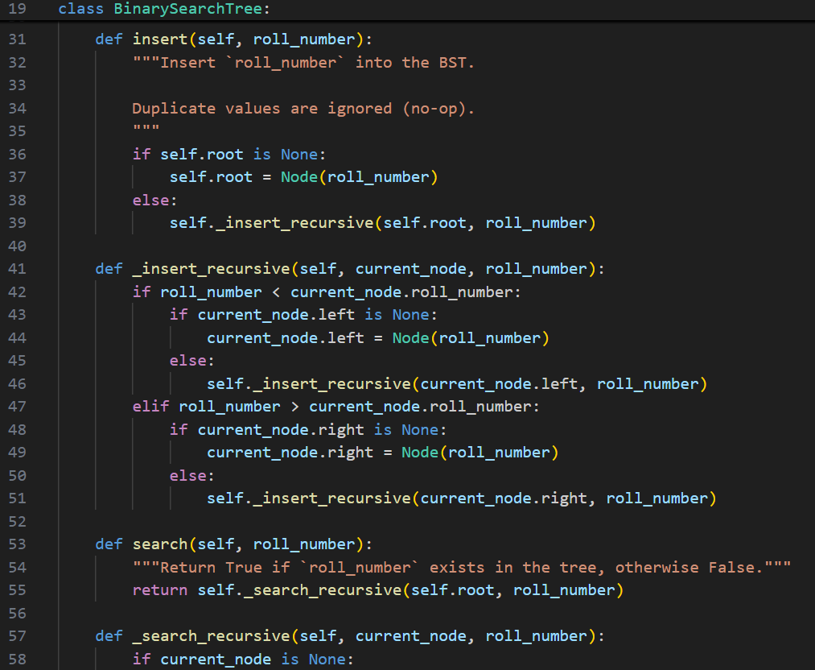
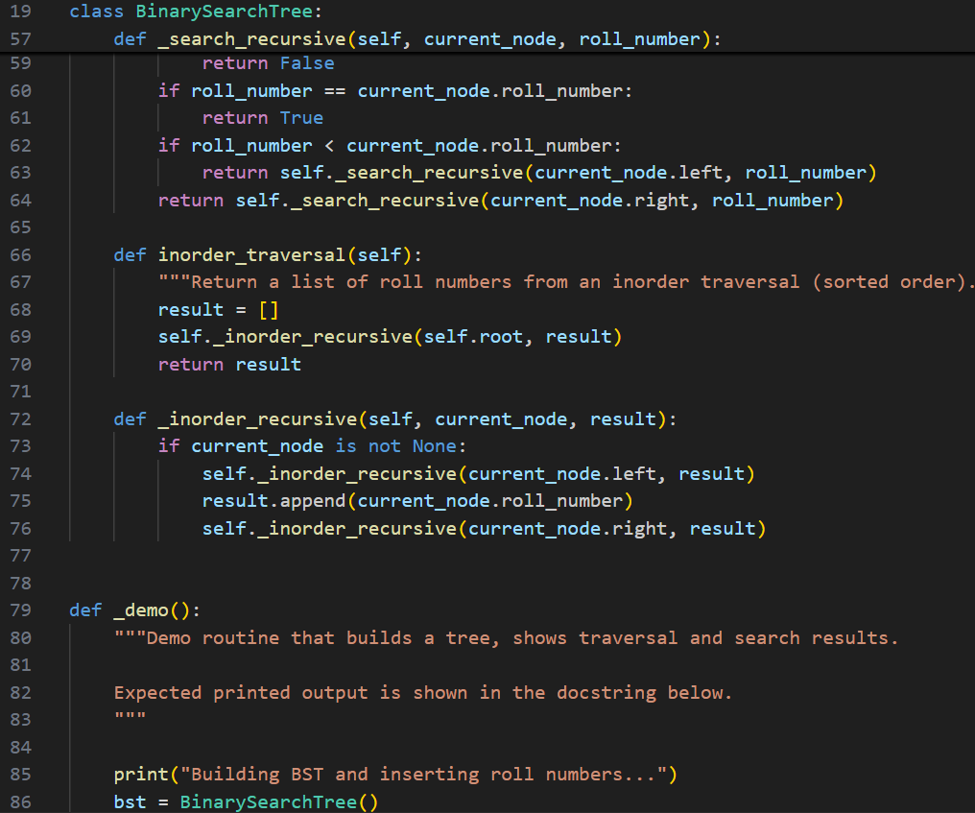
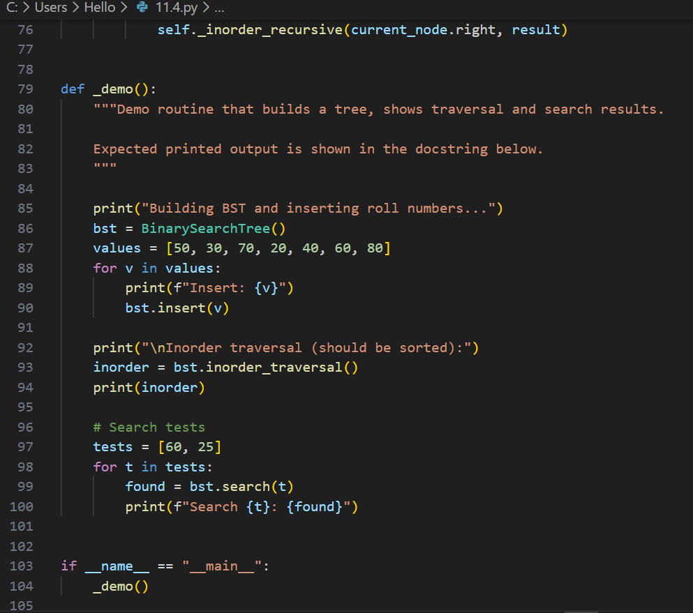
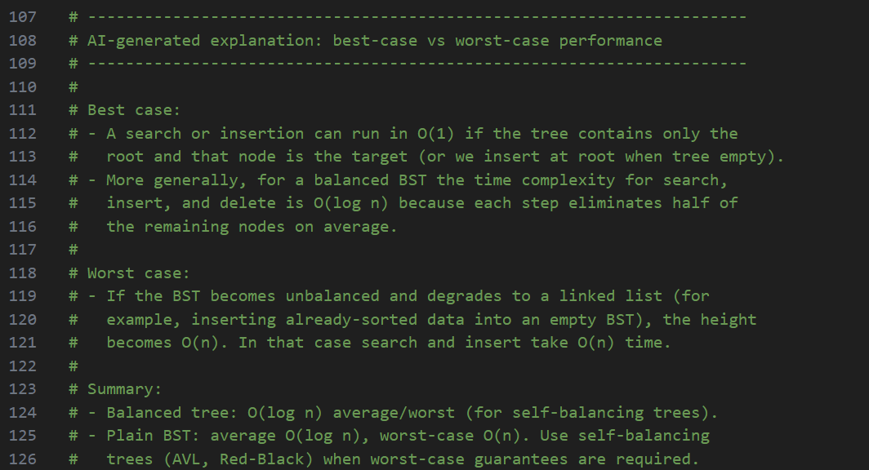

Output:
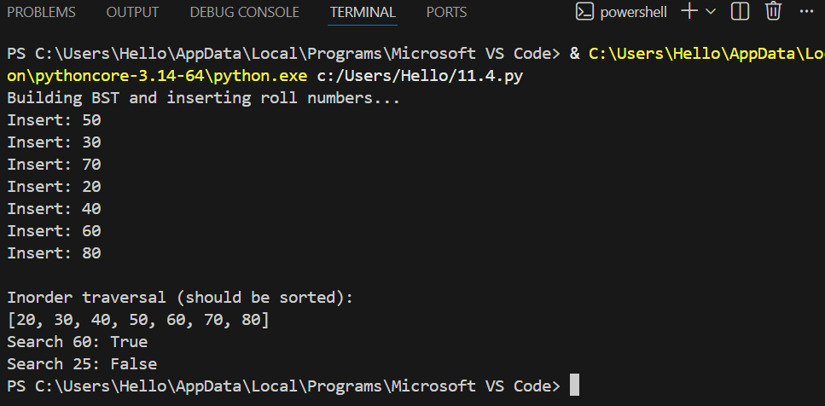

Justification:
Student records require fast searching by roll number.Binary Search Trees store data in a sorted hierarchical structure.This reduces search time compared to linear search.
Best-case search occurs in logarithmic time.Worst-case occurs when the tree becomes skewed.BSTs improve efficiency for large datasets.

Task 5: Graph Traversal for Social Network Connections
Scenario
You are modeling a social network, where users are connected to friends, and
you want to explore connections.

Prompt:
Design a Python program to model a social network using a graph represented as an adjacency list.
Implement Breadth-First Search (BFS) to find nearby or immediate connections between users.
Implement Depth-First Search (DFS) to explore deeper connection paths in the network.
Add inline comments explaining each step of BFS and DFS traversal.
Compare recursive DFS vs iterative DFS, and explain their advantages and limitations.
Finally, suggest practical real-world use cases where BFS is preferred over DFS and vice versa.

Code:
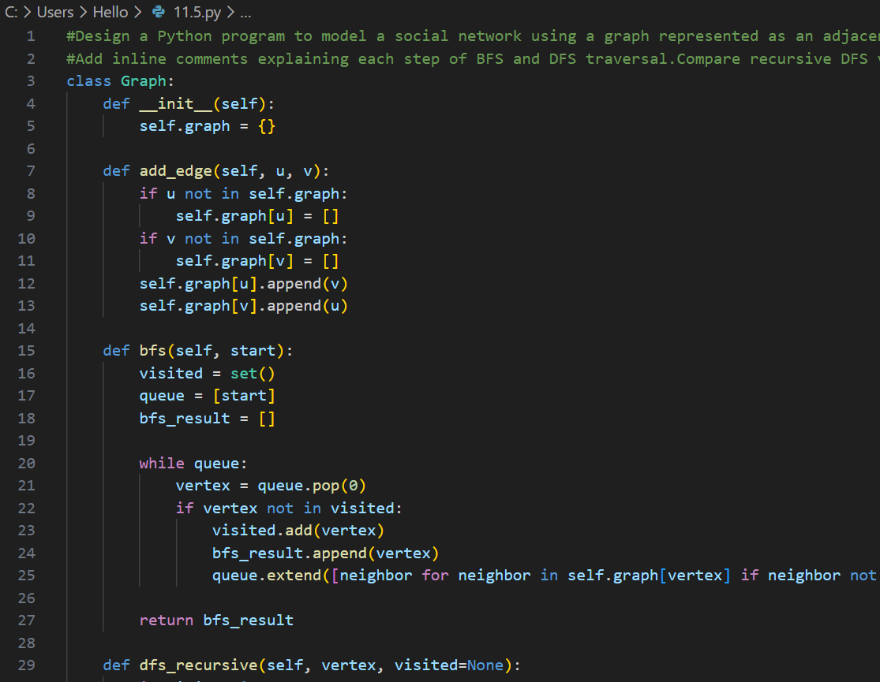
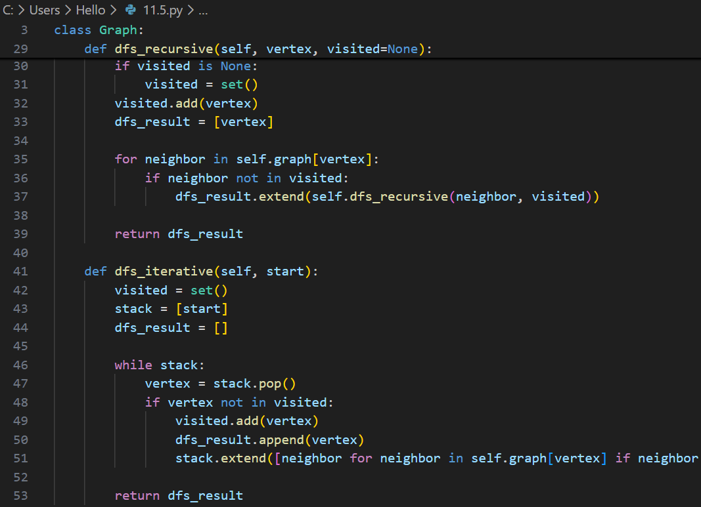
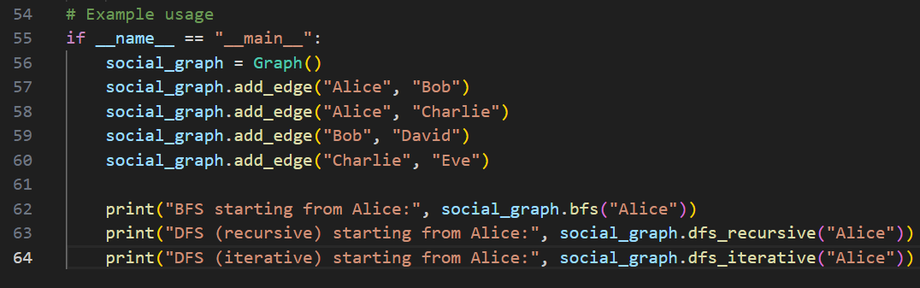

Output:
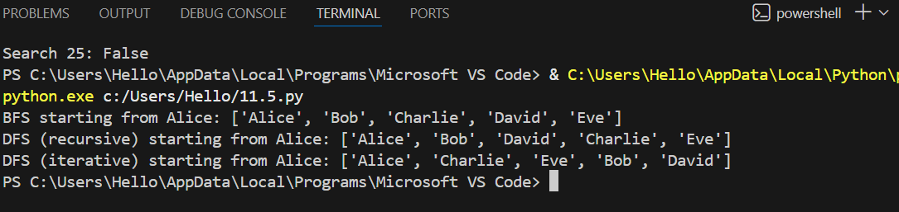

Justification:
Social networks consist of users connected in complex relationships.Graphs accurately represent these connections using nodes and edges.
BFS helps find nearby or mutual connections quickly.DFS explores deep connection paths efficiently.
Traversal helps analyze relationships and recommendations.Graphs support real-world network modeling effectively.

